Rest Assured is a Java library (api) to test restful web services (Or Rest Services)

SOAP - Simple Object Architecture Protocol (communication mechanism)

To test xml and Json based web services.

Supports post, get, put, delete, options, patch , head

Can be integrated with Junit, TestNG, etc…

Rest Assured is implemented in Groovy

We can use BDD - Given/When/Then
BDD stands for Behavior Driven Development.

Website: www.rest-assured.io

Prerequisites:

Java, Eclipse IDE for java dev, maven, TESTNG

1. Open Eclipse

2. Create a Maven project

3. Add dependencies to pom.xml of testng, and rest assured

4. Create a class in src/test/java

What is REST?
REST stands for Representational (Data) State Transfer. REST is a set of constraints that were put forth by Roy Fielding.

Data can be represented in the form of:
- Xml
- JSON

REST Constraints

1) Client – Server Architecture style

According to this constraint, an application should be modeled like a Client – Server. To relate to it, applications should have the UI separate from the Data. There should be a distinct component handling Front end (UI) and the Back end (Database).

The importance of this style of design is that the Client and Server components can evolve independently. Also, most important part is that a Server can serve multiple Clients, Clients can further be on different technologies

2) Stateless

Server should not store the context of the Client. Each request sent by the Client should not be treated with any information (context) from previous requests made by the same client.

3) Cache

According to this constraint, Responses from the server should contain relevant information to tell whether the Response can be cached by the client or not. Usually this is done via a Header entry in the Response.

This constraint improves the client efficiency, for cacheable responses Client need not make requests to the server. Clients can simply look into its cache for the Response. This saves network bandwidth and Client processing power.

4) Uniform Interface

The uniform interface simplifies and decouples the architecture, which enables each part to evolve independently. The four guiding principles of this interface are:
- Identification of resources
- Manipulation of resources through these representations
- Self-descriptive messages
- Hypermedia as the engine of application state (A.K.A. HATEOAS)

5) Layered System

According to this constraint the system implementation should be layered. Each layer abstracting out certain functionality of the overall system. A layer should not know about the existence of other layers apart from the layers that it directly interacts with.

6) Code on demand

This is an optional constraint that RESTful architecture imposes. According to this constraint a client can extend its functionality by downloading code from the Server This code can come in the form of Applets or Scripts. Javascript is one example of how code on demand can help clients extend their functionalities.

What are Rest Architectural Elements?
Rest Architectural style defines parts of Restful service as key conceptual elements. For e.g. while we make a Rest request to a Server, the information returned by the Server is called a Resource. Let us take a quick look at the key conceptual elements in a RESTful Web Service.
Element | Example
Resource | Information stored on a Server, which can be requested by a client. It could be Weather info or may be employee details
Resource Identifier | Now that we have a resource defined, we need to uniquely identify the resource. That is actually the complete URL
Representation | A resource is the actual data. Now this data can be represented as an XML, HTML or may be simple text. That is what is called a Representation
Representation Metadata | In order for the Clients to specify and process resources given in a particular Representation (XML or HTML etc) some extra data (Metadata) needs to be passed in the request.

How to Write REST API Test using Rest Assured?

import org.testng.annotations.Test;
import io.restassured.RestAssured;
import io.restassured.http.Method;
import io.restassured.response.Response;
import io.restassured.specification.RequestSpecification;

public class SimpleGetTest {

@Test
public void GetWeatherDetails()
{
// Specify the base URL to the RESTful web service
RestAssured.baseURI = "https://demoqa.com/utilities/weather/city";

// Get the RequestSpecification of the request that you want to send
// to the server. The server is specified by the BaseURI

RequestSpecification httpRequest = RestAssured.given();

// Make a request to the server by specifying the method Type and the method URL.
// This will return the Response from the server. Store the response in a //variable.
Response response = httpRequest.request(Method.GET, "/Hyderabad");

// Now let us print the body of the message to see what response
// we have received from the server
String responseBody = response.getBody().asString();
System.out.println("Response Body is => " + responseBody);

}

}

The above code will produce the same response which was received when opened the same URL on a browser. Here is how the response will be printed in Eclipse console window.
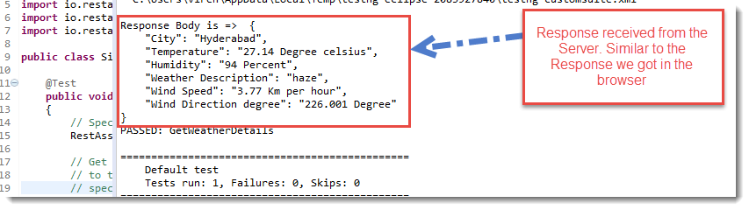

Rest-Assured provides a lot of shorthand methods which can help you write short code. The above test method can be written in a little different way, here is the code snippet. Please go through the code comments to understand the usage.
@Test
public void GetWeatherDetailsCondensed()
{
// Specify the base URL to the RESTful web service
RestAssured.baseURI = "https://demoqa.com/utilities/weather/city";

// Get the RequestSpecification of the request that you want to send
// to the server. The server is specified by the BaseURI that we have
// specified in the above step.
RequestSpecification httpRequest = RestAssured.given();

// Make a GET request call directly by using RequestSpecification.get() method.
// Make sure you specify the resource name.
Response response = httpRequest.get("/Hyderabad");

// Response.asString method will directly return the content of the body
// as String.
System.out.println("Response Body is => " + response.asString());
}

How to Validate Response Status Code?

Response is an interface which lives in the package: io.restassured.response. This interface has lots of methods, mostly methods which can help to get parts of the received response.
A simple Response followed by a dot (Response). in eclipse would shown the available methods on the interface. As shown in the image below
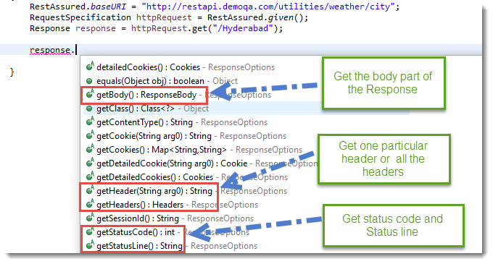
Notice, getStatusCode() method can be used to get the status code of the Response. This method returns an integer and the test will verify the value of this integer. TestNG Assert is used to verify the Status Code.
@Test
public void GetWeatherDetails()
{
RestAssured.baseURI = "https://restapi.demoqa.com/utilities/weather/city";
RequestSpecification httpRequest = RestAssured.given();
Response response = httpRequest.get("/Hyderabad");

// Get the status code from the Response. In case of
// a successfull interaction with the web service, we
// should get a status code of 200.
int statusCode = response.getStatusCode();

// Assert that the correct status code is returned.
Assert.assertEquals(statusCode /*actual value*/, 200 /*expected value*/, "Correct status code returned");
}

Similarly, we can validate statusLine etc…

Validate Response Header using Rest Assured
Every response that is received from a server contains zero or more headers. Headers are the part of Response that is sent by the server. Each header entry is basically a Key-Value pair. Headers are used to send across extra information by the server. This extra information is also referred to as Metadata of the Response.

How to read different Header Types from HTTP Response?
Let's just see how to read a Header using Rest-Assured. To do that let's do a simple exercise in which the test would record the following Header Types from the Response:
- Content-Type
- Server
- Content-Encoding
The Response interface provides direct methods to access individual header or all the Headers. Simply do a Response followed by a dot (Response.head), all the available methods to get headers will be displayed. Below image shows the available methods
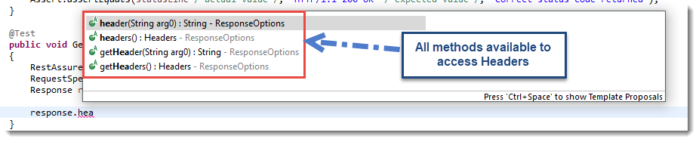
In the below code, .header(String arg0) method is used to get a particular header. In the argument of this method pass the exact header name.
@Test
public void GetWeatherHeaders()
{
RestAssured.baseURI = "https://restapi.demoqa.com/utilities/weather/city";
RequestSpecification httpRequest = RestAssured.given();
Response response = httpRequest.get("/Delhi");

// Reader header of a given name. In this line we will get
// Header named Content-Type
String contentType = response.header("Content-Type");
System.out.println("Content-Type value: " + contentType);

// Reader header of a give name. In this line we will get
// Header named Server
String serverType = response.header("Server");
System.out.println("Server value: " + serverType);

// Reader header of a give name. In this line we will get
// Header named Content-Encoding
String acceptLanguage = response.header("Content-Encoding");
System.out.println("Content-Encoding: " + acceptLanguage);
}

In this code we are trying to get the Content-Type, Server and Content-Encoding headers. The exact values will be printed out in the Console window using the System.out.println statement. The out of this test looks like this
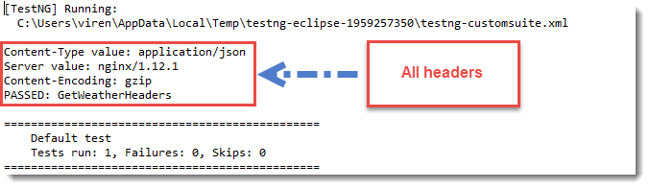
Note: Response.GetHeader(String headerName) method does exactly the same thing as the Response.Header(String headerName) method does. So the above can be written by replacing .Header with .GetHeader. Try it out yourself.

How to Print all the Headers from HTTP Response?
All the headers in a Response can also be printed by simply iterating over each Header. Response interface provides two methods
- headers() : returns Headers
- getHeaders() : returns Headers
This collection is represented by a class called io.restassured.http.Headers. Headers class implements the Iterable interface. Hence, for each (for( : )) loop can be used to read all the headers, as shown in the code below:
@Test
public void IteratingOverHeaders()
{
RestAssured.baseURI = "https://restapi.demoqa.com/utilities/weather/city";
RequestSpecification httpRequest = RestAssured.given();
Response response = httpRequest.get("/Delhi");

// Get all the headers. Return value is of type Headers.
// Headers class implements Iterable interface, hence we
// can apply an advance for loop to go through all Headers
// as shown in the code below
Headers allHeaders = response.headers();
// Headers h = response.getHeaders()
// Iterate over all the Headers
for(Header header : allHeaders)
{
System.out.println("Key: " + header.getName() + " Value: " + header.getValue());
}
}

How to Validate Response Header using Rest Assured?

@Test
public void GetWeatherHeaders()
{
RestAssured.baseURI = "https://restapi.demoqa.com/utilities/weather/city";
RequestSpecification httpRequest = RestAssured.given();
Response response = httpRequest.get("/Delhi");

// Read header of a given name. In this line we will get
// Header named Content-Type
String contentType = response.header("Content-Type");
Assert.assertEquals(contentType /* actual value */, "application/json" /* expected value */);

// Read header of a given name. In this line we will get
// Header named Server
String serverType = response.header("Server");
Assert.assertEquals(serverType /* actual value */, "nginx/1.12.1" /* expected value */);

// Read header of a given name. In this line we will get
// Header named Content-Encoding
String contentEncoding = response.header("Content-Encoding");
Assert.assertEquals(contentEncoding /* actual value */, "gzip" /* expected value */);
}

Read JSON Response Body using Rest Assured

@Test
public void WeatherMessageBody()
{
RestAssured.baseURI = "https://restapi.demoqa.com/utilities/weather/city";
RequestSpecification httpRequest = RestAssured.given();
Response response = httpRequest.get("/Delhi");

// Retrieve the body of the Response
ResponseBody body = response.getBody();

// By using the ResponseBody.asString() method, we can convert the body
// into the string representation.
System.out.println("Response Body is: " + body.asString());
}

ResponseBody interface also has a method called .asString(), as used in the above code, which converts a ResponseBody into its String representation. If you run this test the output will look something like this:
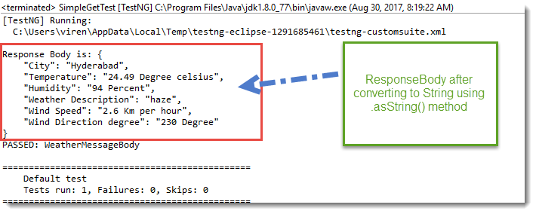
Note: Response.body() method does exactly the same thing. So you can even use the .body() method in the above code.

How to Validate Response Body Contains Some String?

@Test
public void WeatherMessageBody()
{
RestAssured.baseURI = "https://restapi.demoqa.com/utilities/weather/city";
RequestSpecification httpRequest = RestAssured.given();
Response response = httpRequest.get("/Hyderabad");

// Retrieve the body of the Response
ResponseBody body = response.getBody();

// To check for sub string presence get the Response body as a String.
// Do a String.contains
String bodyAsString = body.asString();
Assert.assertEquals(bodyAsString.contains("Delhi") /*Expected value*/, true /*Actual Value*/, "Response body contains Delhi");
}

Check String presence by ignoring alphabet casing

@Test
public void WeatherMessageBody()
{
RestAssured.baseURI = "https://restapi.demoqa.com/utilities/weather/city";
RequestSpecification httpRequest = RestAssured.given();
Response response = httpRequest.get("/Delhi");

// Retrieve the body of the Response
ResponseBody body = response.getBody();

// To check for substring presence get the Response body as a String.
// Do a String.contains
String bodyAsString = body.asString();

// convert the body into lower case and then do a comparison to ignore casing.
Assert.assertEquals(bodyAsString.toLowerCase().contains("delhi") /*Expected value*/, true /*Actual Value*/, "Response body contains Delhi");
}
The above two approaches suffer from a classical problem, what if the string "Delhi" is present in a wrong node or may be multiple instances of the same string are present.

This is not a fool proof way of testing a particular node in the Response. There are better ways, Response interface gives you a mechanism to extract nodes based on a given JsonPath.

There is a method called Response.JsonPath(), which returns a io.restassured.path.json.JsonPath Object. This object can be used to further query specific parts of the Response Json.

How to Extract a Node text from Response using JsonPath?

Let us look at the Weather API response again.
{
"City": "Hyderabad",
"Temperature": "25.51 Degree celsius",
"Humidity": "94 Percent",
"Weather Description": "mist",
"Wind Speed": "1 Km per hour",
"Wind Direction degree": " Degree"
}

@Test
public void VerifyCityInJsonResponse()
{
RestAssured.baseURI = "https://restapi.demoqa.com/utilities/weather/city";
RequestSpecification httpRequest = RestAssured.given();
Response response = httpRequest.get("/Hyderabad");

// First get the JsonPath object instance from the Response interface
JsonPath jsonPathEvaluator = response.jsonPath();

// Then simply query the JsonPath object to get a String value of the node
// specified by JsonPath: City (Note: You should not put $. in the Java code)
String city = jsonPathEvaluator.get("City");

// Let us print the city variable to see what we got
System.out.println("City received from Response " + city);

// Validate the response
Assert.assertEquals(city, "Hyderabad", "Correct city name received in the Response");

}

The output of the code passes the assertion and it also prints the City name retrieved from the Response. As shown in the image below
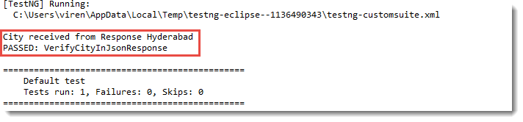

Sample Code to read all the nodes from Weather API Response

@Test
public void DisplayAllNodesInWeatherAPI()
{
RestAssured.baseURI = "https://restapi.demoqa.com/utilities/weather/city";
RequestSpecification httpRequest = RestAssured.given();
Response response = httpRequest.get("/Hyderabad");

// First get the JsonPath object instance from the Response interface
JsonPath jsonPathEvaluator = response.jsonPath();

// Let us print the city variable to see what we got
System.out.println("City received from Response " + jsonPathEvaluator.get("City"));

// Print the temperature node
System.out.println("Temperature received from Response " + jsonPathEvaluator.get("Temperature"));

// Print the humidity node
System.out.println("Humidity received from Response " + jsonPathEvaluator.get("Humidity"));

// Print weather description
System.out.println("Weather description received from Response " + jsonPathEvaluator.get("Weather"));

// Print Wind Speed
System.out.println("City received from Response " + jsonPathEvaluator.get("WindSpeed"));

// Print Wind Direction Degree
System.out.println("City received from Response " + jsonPathEvaluator.get("WindDirectionDegree"));
}

Understand how to send a request with Query Parameters in Rest Assured?

The full-service URL with the endpoint is: https://samples.openweathermap.org/data/2.5/weather?q=London,uk&appid=2b1fd2d7f77ccf1b7de9b441571b39b8
Head | Head
Endpoint | https://samples.openweathermap.org/data/2.5/weather?q=London,uk&appid=2b1fd2d7f77ccf1b7de9b441571b39b8
HTTP Method Type | GET
Query Parameters | Key:
 | q: London, UK
 | appid: 2b1fd2d7f77ccf1b7de9b441571b39b8
Body | We don’t need to pass the body for GET request in this example.
Success Response
200 Status OK

{
“coord”: {
“lon”: -0.13,
“lat”: 51.51
},
“weather”: [
{
“id”: 300,
“main”: “Drizzle”,
“description”: “light intensity drizzle”,
“icon”: “09d”
}
],
“base”: “stations”,
“main”: {
“temp”: 280.32,
“pressure”: 1012,
“humidity”: 81,
“temp_min”: 279.15,
“temp_max”: 281.15
},
“visibility”: 10000,
“wind”: {
“speed”: 4.1,
“deg”: 80
},
“clouds”: {
“all”: 90
},
“dt”: 1485789600,
“sys”: {
“type”: 1,
“id”: 5091,
“message”: 0.0103,
“country”: “GB”,
“sunrise”: 1485762037,
“sunset”: 1485794875
},
“id”: 2643743,
“name”: “London”,
“cod”: 200
}

import org.testng.Assert;
import org.testng.annotations.Test;
import io.restassured.RestAssured;
import io.restassured.response.Response;
import io.restassured.specification.RequestSpecification;

public class QUERYPARAMETERRequest {

@Test
public void queryParameter() {

RestAssured.baseURI ="https://samples.openweathermap.org/data/2.5/";
RequestSpecification request = RestAssured.given();

Response response = request.queryParam("q", "London,UK")
.queryParam("appid", "2b1fd2d7f77ccf1b7de9b441571b39b8")
.get("/weather");
String jsonString = response.asString();
System.out.println(response.getStatusCode());
Assert.assertEquals(jsonString.contains("London"), true);
}
}

POST Request using Rest Assured

Step 1: Create a Request pointing to the Service Endpoint
RestAssured.baseURI ="https://restapi.demoqa.com/customer";
RequestSpecification request = RestAssured.given();
Step 2: Create a JSON request which contains all the fields
// JSONObject is a class that represents a Simple JSON.
// We can add Key - Value pairs using the put method
JSONObject requestParams = new JSONObject();
requestParams.put("FirstName", "Amit");
requestParams.put("LastName", "Gupta");
requestParams.put("UserName", "amit_user001");
requestParams.put("Password", "password1");
requestParams.put("Email", "someuser@gmail.com");

JSONObject is a class that is present in org.json.simple package. This class is a programmatic representation of a JSON string.

Each node can be added using the JSONObject.put(String, String) method.

Once you have added all the nodes you can get the String representation of JSONObject by calling JSONObject.toJSONString() method.

Step 3: Add JSON body in the request and send the Request
// Add a header stating the Request body is a JSON
request.header("Content-Type", "application/json");

// Add the Json to the body of the request
request.body(requestParams.toJSONString());

// Post the request and check the response
Response response = request.post("/register");
Step 4: Validate the Response
Once we get the response back, all we have to do is validate parts of the response. Let us validate the Success Code text in the Response, we will be using JsonPath.
int statusCode = response.getStatusCode();
Assert.assertEquals(statusCode, "201");
String successCode = response.jsonPath().get("SuccessCode");
Assert.assertEquals( "Correct Success code was returned", successCode, "OPERATION_SUCCESS");

Here is the complete code for the above example
@Test
public void RegistrationSuccessful()
{
RestAssured.baseURI ="https://restapi.demoqa.com/customer";
RequestSpecification request = RestAssured.given();

JSONObject requestParams = new JSONObject();
requestParams.put("FirstName", "Amit"); // Cast
requestParams.put("LastName", "Gupta");
requestParams.put("UserName", "user2dd2021");
requestParams.put("Password", "password1");

requestParams.put("Email", "amt_121@gmail.com");
request.body(requestParams.toJSONString());
Response response = request.post("/register");

int statusCode = response.getStatusCode();
Assert.assertEquals(statusCode, "201");
String successCode = response.jsonPath().get("SuccessCode");
Assert.assertEquals( "Correct Success code was returned", successCode, "OPERATION_SUCCESS");
}

Changing the HTTP Verb on a POST Request
One of the key aspects of Web service testing is to verify negative scenarios on the Endpoint. There could be many negative scenarios, some of them are
- Sending incomplete POST Data
- Sending JSON data with incorrect syntax
- Sending incorrect Verb in the Request.

Let us see what the impact will be if we send a GET request to an Endpoint that expects POST.

public void RegistrationSuccessful()
{
RestAssured.baseURI ="https://restapi.demoqa.com/customer";
RequestSpecification request = RestAssured.given();

JSONObject requestParams = new JSONObject();
requestParams.put("FirstName", "Virender"); // Cast
requestParams.put("LastName", "Singh");
requestParams.put("UserName", "sdimpleuser2dd2011");
requestParams.put("Password", "password1");
requestParams.put("Email", "sample2ee26d9@gmail.com");

request.body(requestParams.toJSONString());
Response response = request.get("/register");

int statusCode = response.getStatusCode();
System.out.println("The status code recieved: " + statusCode);

System.out.println("Response body: " + response.body().asString());
}

If you run this test the following output is generated. In the output we can clearly see that the Response body tells us about the incorrect usage of HTTP Verb. The HTTP verb is also known as the Method types, given we actually make a remote method call and specify the type of the method call.
